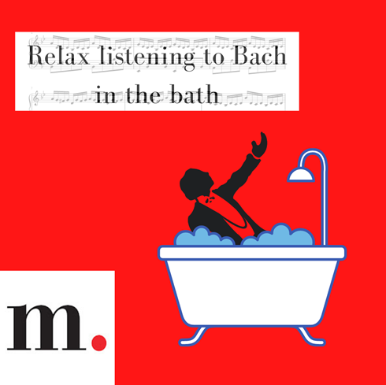
Are you the kind of person who enjoys many genres of music? If you’re feeling classic curious, check out all Medici has to offer right now for free. You could be listening to Bach in the bath in no time!

Are you feeling classic curious? Start your journey with Medici and try out some subscribers favourites from this spring
https://edu.medici.tv/en/collections/top-programs-spring-2021/

